Performance Review Report
Engagement analysis, insights and next-cycle strategy
Prepared for: Aarav Sharma | Persona: Job Seeker
Project code LIL-2025-P1 | Generated 2026-11-09 | DEMO DATA

This report was generated from SIMULATED demo metrics to preview the layout. Replace with real engagement data and rebuild before submitting.

1. Executive summary
Posts | Impressions | Likes | Comments | Shares | Profile visits | Engagement rate
12 | 18,038 | 636 | 119 | 80 | 317 | 4.63%

2. Charts
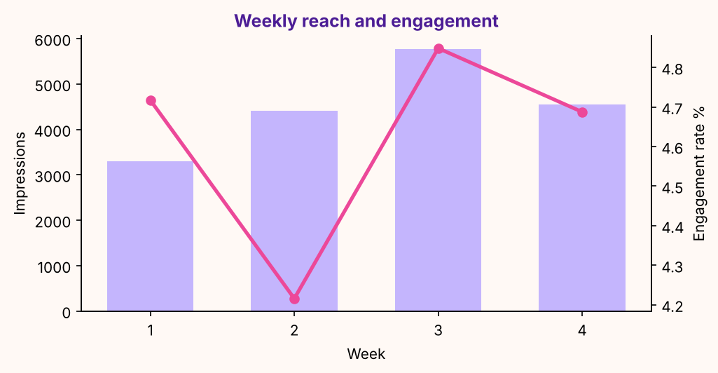
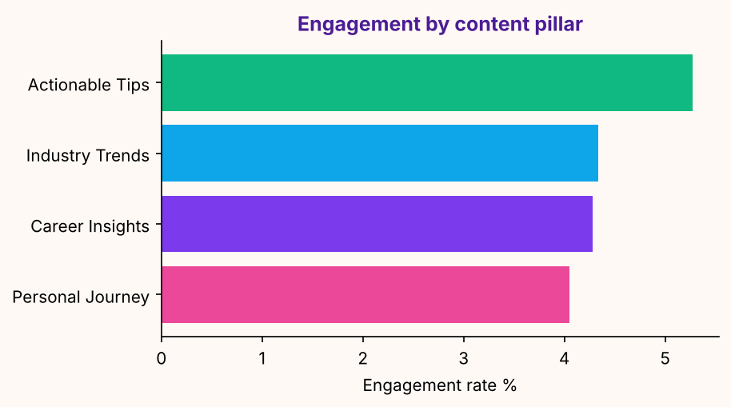
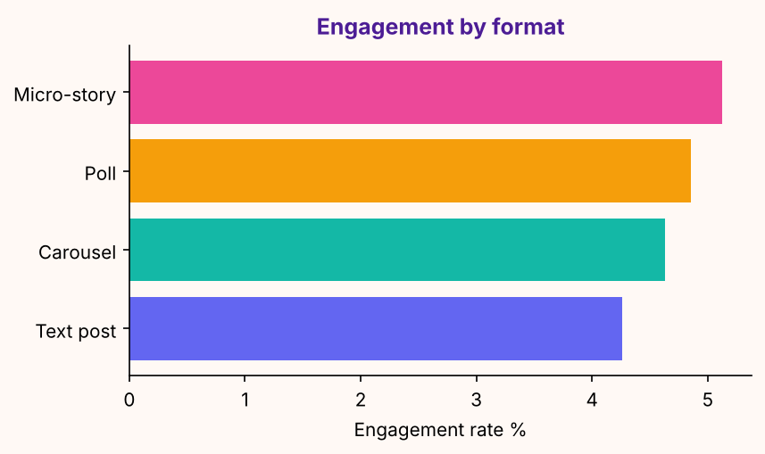

3. Top performing posts
Post | Pillar | Format | Impressions | Engagement | Rate %
D11 | Actionable Tips | Poll | 2031 | 110 | 5.4
D08 | Actionable Tips | Micro-story | 1894 | 106 | 5.6
D09 | Industry Trends | Carousel | 2116 | 98 | 4.6
D05 | Actionable Tips | Poll | 2065 | 96 | 4.6
D07 | Career Insights | Text post | 1765 | 76 | 4.3

4. Insights and recommendations
What we saw | What to do next
'Actionable Tips' is your strongest pillar (5.3% engagement). | Raise its share of the next calendar by about 10 points; keep the others for range.
Micro-story posts perform best (5.1%). | Use this format at least twice a week; test a new hook style inside it.
Wednesday posts lead on engagement. | Move one more post to Wednesday (same time of day) and compare.
Engagement rate is down 1% from first to latest week. | Review the latest week's hooks against the first week's winners.
1.8% of impressions became profile visits. | Make sure the headline and Featured section convert those visits (see the audit).

5. Strategy refinement: next 6-week pillar mix
Pillar | Next share
Actionable Tips | 41%
Personal Journey | 22%
Career Insights | 21%
Industry Trends | 16%

6. Self-assessment against the evaluation criteria
Criterion | Weight | Score
Content Quality & Relevance | 30% | 93.3
Engagement Growth | 20% | 49.7
Personal Branding Alignment | 15% | 100.0
Documentation & Clarity | 10% | 0.0
Overall (provisional) |  | 70.6

7. Risks and mitigations
Risk | Mitigation (brief) | How this project handles it
Low engagement | Adjust posting time and content type | Insights page flags rate < 2% and suggests hook / format / time tests.
Free-tier limits in Taplio | Supplement with manual LinkedIn analytics | Manual entry form and a flexible CSV importer for LinkedIn or Taplio exports.
Over-reliance on AI | Ensure human review for authenticity | Every draft has a Human reviewed gate; the approved-only Taplio queue excludes the rest.
Consistency drop-off | Use scheduling to avoid gaps | Taplio queue, .ics reminders and a consistency score on the dashboard.

